Computer Language Diagrams

Label & Goto in a Diagram
The concept of labels and goto is covered by the article Label & Goto. The current article only explains its expression in a diagram.

Here is an example of a call to a Goto command:

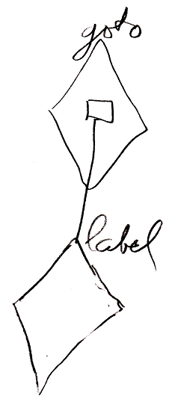

The public contents of the definition of the Goto command look like this:

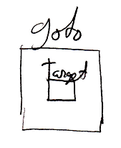

See also: Label & Goto, Normal Execution Order in a Diagram

Author & Copyright: Jan-Joost van Zon Date: June 10, 2008 – June 10, 2008 Location: Oosterhout, The Netherlands Status: Finished

